

**Project Proposal**

**Course: SRE (Spring 2025)**

**Submitted to:**

Dr. Imran Ali Bhatti

**By:**

Hassan K21-3802

Suleman K21-3887

Arqam K21-3826

Zeeshan K21-3919

FAST-NUCES Karachi

**Project Description:**

The goal of this project is to maintain the purchase and sale records for a stationery Store. The store owner purchases inventory from certain suppliers and resells it to Customers. How many products are currently in stock at the store, which products may run out of stock in the first few days, how many products break or get damaged, how much money was sold today, and which vendor received how much money for stock purchases these are the kinds of details that are difficult to record with pen and paper and also take up a lot of time.

**Features**

● View daily purchase, sales and damage report

● View current stock and listing of new product

● Keep track of vendor’s purchases

● Keep track of customer’s sales

**Stakeholders**

● Shop owner

● Customers/Vendors

● Shop Employees (if any)

**User Stories:**

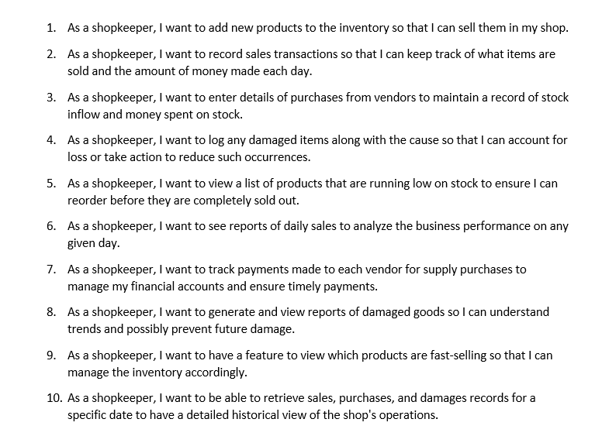

|  |  |
| --- | --- |
| ***Use Case Description*** | |
| ***Use Case name:*** | Add Product |
| ***Use Case Description:*** *user add new product to inventory* | |
| ***Primary actor:*** *Shopkeeper* | ***Other actors:*** |
| ***Stakeholders:*** | Shopkeeper, shop employees |
| ***Relationships***  ▪ ***Includes:***  ▪ ***Extends:*** exclude from login | |
| ***Pre-conditions:*** ▪*must be login* | |
| ***Flow of Events:***   1. *Shopkeeper login the system* 2. *Shopkeeper select option to add new product*   ***3.*** *Shopkeeper enter product details such as name,quantity,price*  ***4.****System Save the product in inventory* | |
| ***Post-conditions:***  ▪product is available for sale | |
|  | |

|  |  |
| --- | --- |
| ***Use Case Description*** | |
| ***Use Case name:*** | Record Sales |
| ***Use Case Description:*** *user record the sale transaction* | |
| ***Primary actor:*** *Shopkeeper* | ***Other actors:*** |
| ***Stakeholders:*** | Shopkeeper, shop employees |
| ***Relationships***  ▪ ***Includes:***  ▪ ***Extends:*** exclude from login | |
| ***Pre-conditions:*** ▪*must be login* | |
| ***Flow of Events:***  ***1.*** *Shopkeeper enter sold item*  ***2.*** *System calculate total cost*   1. *System update inventory* 2. *System record the sale transaction* | |
| ***Post-conditions:***  ▪sale data updated and show | |
|  | |

|  |  |
| --- | --- |
| ***Use Case Description*** | |
| ***Use Case name:*** | Record Purchase |
| ***Use Case Description:*** *user record the Purchase transaction* | |
| ***Primary actor:*** *Shopkeeper* | ***Other actors:*** *Vendors* |
| ***Stakeholders:*** | Shopkeeper, shop employees |
| ***Relationships***  ▪ ***Includes:***  ▪ ***Extends:*** exclude from login | |
| ***Pre-conditions:*** ▪*must be login* | |
| ***Flow of Events:***  ***1.*** *Shopkeeper enter purchase item include cost and quantity*  ***2.*** S*ystem update and record inventory and include new items* | |
| ***Post-conditions:***  ▪Purchase data updated and show | |
|  | |

|  |  |
| --- | --- |
| ***Use Case Description*** | |
| ***Use Case name:*** | Record Damage Items |
| ***Use Case Description:*** *user record the Damage Items* | |
| ***Primary actor:*** *Shopkeeper* | ***Other actors:*** *Vendors* |
| ***Stakeholders:*** | Shopkeeper, shop employees |
| ***Relationships***  ▪ ***Includes:***  ▪ ***Extends:*** exclude from login | |
| ***Pre-conditions:*** ▪*must be login* | |
| ***Flow of Events:***  ***1.*** *Shopkeeper enter damage item include cause and extent of damage*  ***2.*** S*ystem update and record details of damage items* | |
| ***Post-conditions:***  ▪Damage Items updated and show | |
|  | |

**Reverse Engineering**

**Visualization**

**Class Digaram**

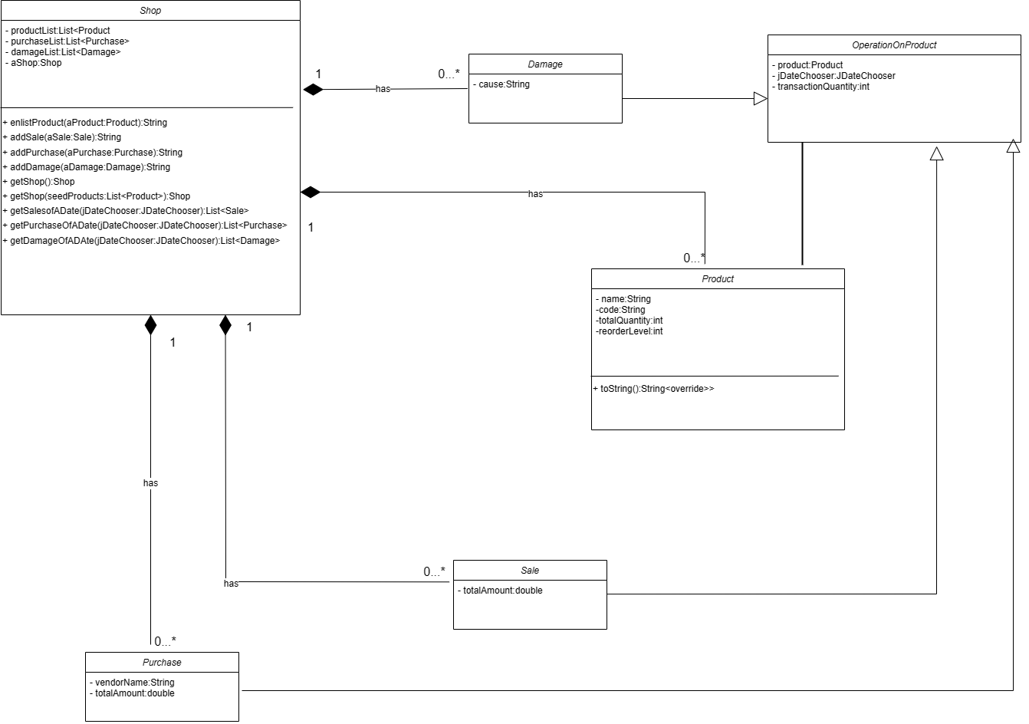

**System Sequence Diagram**

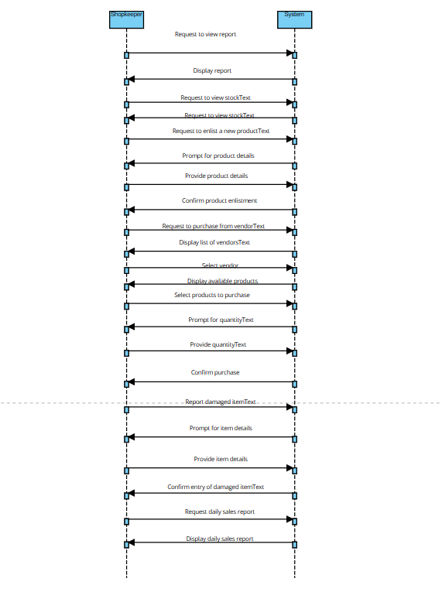

**Sequence Diagram**

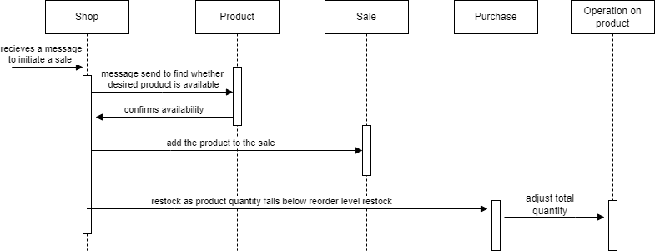

**Forward Engineering**

**New Features:**

* Add a Secure Login Page to maintain and access data in protective way
* Add a Profile Page where Shopkeeper can see the detail of Shop including Location, Shop Timing and Marketing Profile including Facebook and Instagram Page and Shop Website

**New Design**

* New Login Screen For Secure Accessibility

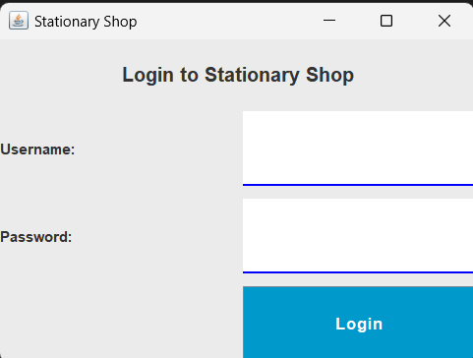

* Old and New Screen of All the Core Function

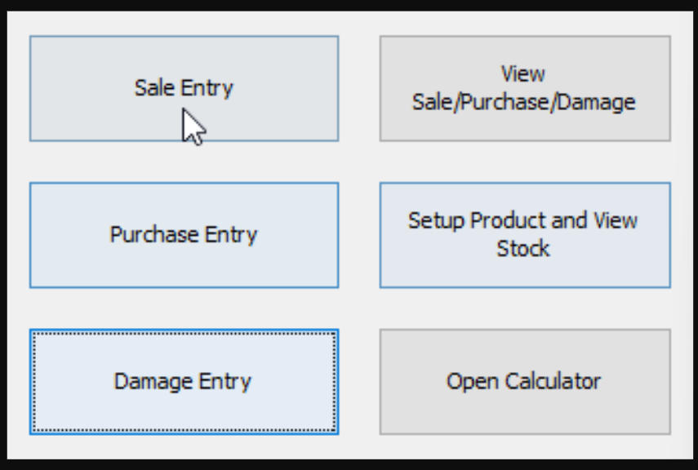

New Screen:  
  
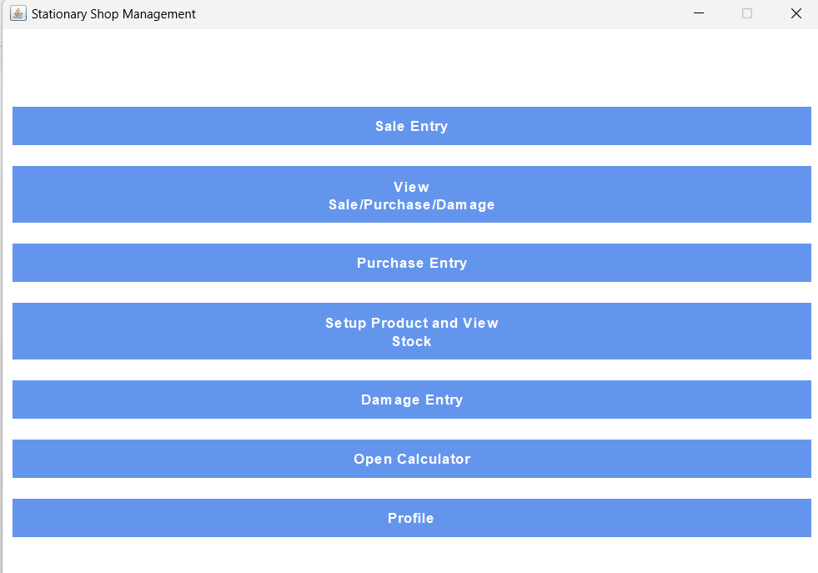

* Created a new Profile Screen which provide Information of Shop

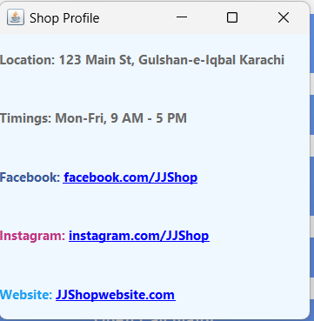

**Code Refactoring**

We have Change the “MainUi.java’ code the old one have several refactoring issues .Below is the comparison between old file and new file in term of code effectiveness and efficiency.

1. **Class Structure:**
   * In the latest version library direct inherited from **JFrame** instead of **javax.swing.JFrame**,this will simplify the import statement
2. **Variable Declaration:**
   * In the latest version, all button has been declared at one place for the better clarity.
3. **Component Initialization:**
   * **initComponents()** has been initialize as private to encapsulate and secure.
4. **Styling:**
   * All the styling of buttons, color etc has been implemented in separate Method for organize the code.
5. **Layout Design:**
   * In the latest version Layout has been implemented using **GridBagLayout**, which make it more flexible.

**Reference Code:**

GITHUB :

<https://github.com/SulemanMohiuddin/Software_ReEnigneering_Project>

_____________________________________________________________________________________